Computer Networks Lab Session

Lab Session Time & Location:
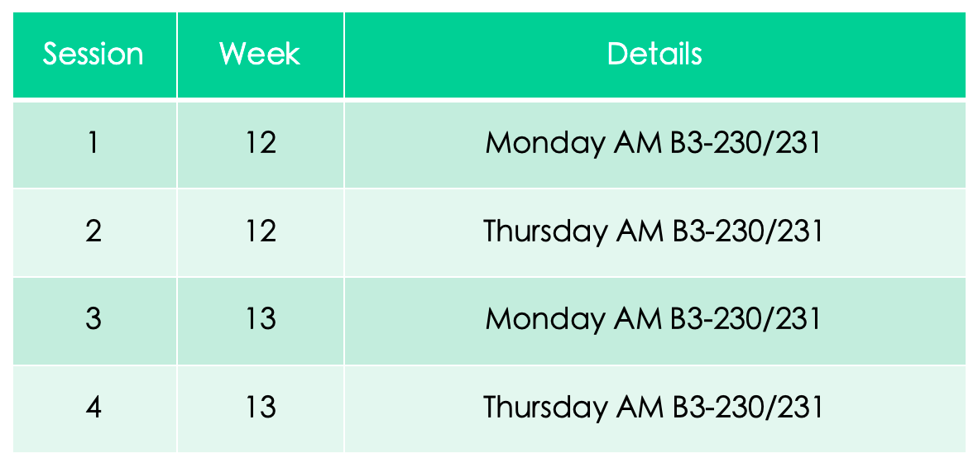

Submissions:
The lab session tasks SHOULD be demoed in the sessions.
Four reports are required to be submitted (One for each task). Your reports should follow the listed requirements:
- Using university lab report template
- Individual report. NO PLAGIARISM.
- Explain the questions listed in task requirements and record your steps and results.
- Store your report in a fold named as “studentID-name”(for example “20200123456789-张三.doc”).

Deadline
Before exam date Dec.18 2023

